Riphah International University Lahore, Pakistan

Riphah School of Computing & Innovation

FINAL YEAR PROJECT
PROJECT PROPOSAL & PLAN

Maveshi Sehat AI
AI-Powered Livestock Health Intelligence Platform for Pakistan

Project ID: []

Project Team
Student Name | Student ID | Program | Contact Number | Email Address
Gulraiz Liaqat | 50759 | BSSE | 03154226275 | Rgulraiz696@gmail.com
Awais Shabbir | 51460 | BSSE | 03054758667 | awaiskamboh0810@gmail.com
Wahib Ali | 45438 | BSSE | 03010480861 | Wahibchoudry78@gmail.com

Ms. Uzma Kiran
lecturer
Maveshi Sehat AI
AI-Powered Livestock Health Intelligence Platform for Pakistan

Change Record

Author(s) | Version | Date | Notes | Supervisor’s Signature

Project Proposal

Project Title: Maveshi Sehat AI

AI-Powered Livestock Health Intelligence Platform for Pakistan

Executive Summary
Maveshi Sehat AI is the new generation AI-powered livestock health intelligence platform that was designed uniquely for Pakistan's agricultural sector. It helps tackle the most critical pain point that farmers face in Pakistan but is never talked about. These farmers are unable to detect any illness among their animals, access vet consultation, and keep structured health records of them.
The livestock industry makes around 60% contribution to agricultural GDP in Pakistan, and millions of households in rural areas depend upon it. Still, livestock healthcare in Pakistan relies on entirely manual and reactionary efforts of farmers who wait until their animals show some signs of illness and then seek vet consultations. By the time, the problem might be quite difficult to solve as the illness could have spread by then.
Maveshi Sehat AI solves the problem in a simple yet effective way and offers an end-to-end AI-powered solution for farmers' livestock. The technology enables farmers to detect livestock illnesses, estimate BCS, predict heat stress events based on environmental conditions and connect them to veterinarians through telemedicine dashboard. The platform includes an AI chatbot (multilingual; Urdu & Punjabi), community discussion forum, smart vaccine scheduling, and medicine marketplace.
The software is based on a strong three-layer software architecture, which consists of Presentation layer, Business Logic layer, and Data Management layer, running on cloud platforms (AWS/Azure), including the React Native application and React.js dashboard for veterinarians/admins. The training of AI models is done using TensorFlow/PyTorch, using a dataset of 1500 to 3000 annotated pictures of livestock. The development process employs Agile Scrum methodology, 8 biweekly sprints in total.

Introduction
Farming of livestock is an extremely crucial aspect of the Pakistani agricultural sector as it earns around 60 percent of its total agricultural revenue and provides employment to about 35 million people living in rural regions.

Pakistan holds a high rank among all other nations in terms of the quantity of livestock; more than 200 million animals including cows, buffaloes, goats, sheep, and poultry are available in Pakistan. However, in spite of having such a large number of animals, an efficient health management system for these animals is missing.

Most of the farmers in rural regions of Punjab, Sindh, KPK, and Balochistan lack proper access to veterinary doctors. The ratio of one veterinarian to 15,000 animals is much less than global standards.

Thus, the only way of detecting illness in animals is by farmers through their own observations which results in delayed detection.

This leads to a number of issues:

Low milk yield

High mortality rate among livestock

Loss of money as a result of spoiled meat

Costly medical intervention in emergencies

The common illnesses that cost farmers substantial amounts of money each year include FMD, LSD, mastitis, and hemorrhagic septicemia. Many of these illnesses could be easily avoided through early identification.

Maveshi Sehat AI came to solve this issue. This technology functions similarly to an intelligent veterinary assistant for farmers, and it is accessible 24/7. To use it, a farmer needs only a smartphone and an internet connection.

The benefits provided by Maveshi Sehat AI for farmers are:

Disease detection in livestock with the use of artificial intelligence
Instantaneous provision of helpful suggestions
Connecting farmers with experienced veterinarians

To summarize, Maveshi Sehat AI provides advanced veterinary care directly to farmers.

- Existing System / Competitive Analysis
Currently, the management of animal health in Pakistan is still a manual process. Farmers use their own observation and sometimes consult veterinarians. There are a few digital platforms available in Pakistan that focus mainly on record-keeping and managing the farm but do not focus on the early detection of diseases.

- Maveshi App:
The first app for managing animal health in Pakistan. The app allows farmers to record their cattle, vaccinations, and fodder. The app is useful for record-keeping but does not use AI for detecting diseases.

- Nizi Solutions Livestock Management System:
This is a software-based platform designed for large-scale farming operations. This platform is suitable for commercial farming operations rather than small-scale farming operations in the rural area.

- Kissanai Analytics:
This is an AI-based platform that offers data analysis for farming operations. This platform is still in the growing stage and is not widely adopted among farmers.

COMPARISON:
APPLICATIONS | MAIN FEATURES | LIMITATIONS | TECHNOLOGY SUPPORT | DIFFERENCE FROM Maveshi Sehat AI
MAVESHI | Animal record keeping, vaccination logs, fodder/medicine stock, financial reports | It only focuses on record-keeping and does not have AI for disease detection, predictive analysis, or integration with vets | Mobile app, cloud database | Maveshi Sehat offers AI disease detection, body scoring, heat stress prediction, vet dashboard, and medicine marketplace
NIZI SOLUTION | Digital animal records for cattle/poultry, veterinary regulations, productivity tracking | It is mainly for use by large organizations and is very expensive and inaccessible for small rural farmers | Web-based system, enterprise software | Maveshi Sehat AI is affordable, farmer-friendly, and accessible on low-end smartphones even with low internet connectivity
KISSANAI ANALYTICS | AI-based farm data analysis, suggestions, expert assistance | It is still in development and does not have direct image-based disease detection | Web platform with analytics | Maveshi Sehat AI offers direct photo-based disease detection, vaccination alerts, and medicine ordering services
MAVESHI SEHAT AI | AI-based disease prediction, body condition scoring, heat stress prediction, vaccination reminders, digital health records, vet's dashboard, medicine marketplace | It is still in development and collecting data for training | Flutter mobile app, React.js dashboard, Python AI models, cloud deployment | Maveshi Sehat AI is an affordable AI-based detection system that offers services through a vet dashboard and medicine marketplace, exclusively designed for Pakistani farmers

Features-Wise Comparison
FEATURE | MAVESHI | NIZI SOLUTION | KISSANI ANALYTICS | MAVESHI SEHAT AI
AI Image-Based Disease Detection | ✗ | ✗ | ✗ | ✓
Body Condition Scoring (BCS) | ✗ | ✗ | ✗ | ✓
Heat Stress Prediction | ✗ | ✗ | ✗ | ✓
Telemedicine / Vet Dashboard | Minimal | Minimal | ✗ | ✓
AI-Chatbot (Urdu/Punjabi) | ✗ | ✗ | ✗ | ✓
In-App Medicine Marketplace | Stock only | Enterprise | ✗ | ✓
Community Forum & Peer Sharing | ✗ | ✗ | ✗ | ✓
Digital Health Records | ✓ | ✓ | ✓ | ✓
Vaccination Reminders & Alerts | ✓ | ✓ | ✗ | ✓
Offline Support (Planned) | ✗ | ✗ | ✗ | Planned
Low-End Device Support | ✗ | ✗ | ✗ | ✓
Urdu / Punjabi Language Support | ✗ | ✗ | ✗ | ✓
Analytics Dashboard for NGO/Gov | ✗ | ✗ | ✗ | ✓
Target Audience | Small farms | Large enterprise | Tech-savvy farmers | Rural farmers, NGOs, Govt

- Problem Statement
Livestock is a major sector for Pakistan, contributing around 60% to the country’s agricultural GDP. However, the management of livestock health is still conducted manually. This results in:

- Less milk production
- Increased cost of treatment
- Increased mortality rate
- Language issue
- Productivity loss

Challenges:

- Diseases are detected too late, as the methods used are only based on observing the disease visually.
- No health records, making it difficult to know the history of the animal.
- Vets are not always readily available, causing delays in treatment for the animals.
- No consistent checkups, as there are no tools for doing so.
- No AI solutions available for the Pakistani ecosystem.

Proposed Solution
AI Maveshi Sehat is a comprehensive, full-stack, cloud-native, and AI-enabled platform for livestock health intelligence. The platform offers a user-friendly mobile app to farmers along with a telemedicine platform dashboard for veterinarians. The platform includes nine key modules such as:

Module | Description
Module 1: AI Disease Detection Engine | Real-time detection of livestock diseases from farmer-captured images using CNN-based models (ResNet50, MobileNetV2). Detects skin infections, swellings, eye discharge, and more. Trained on 1,500–3,000+ labeled images with 85%+ target accuracy.
Module 2: Body Condition Scoring (BCS) | Automated assessment of livestock body condition from lateral images using regression-based deep learning. Provides nutritional status, weight estimation, and feeding recommendations without manual weighing.
Module 3: Heat Stress Prediction | Predictive model integrating real-time weather data (Temperature-Humidity Index), breed characteristics, and historical patterns using Random Forest / Gradient Boosting classifiers. Issues 24–48-hour advance alerts.
Module 4: Digital Health Records & Vaccination | Structured per-animal health profiles including disease history, vaccinations, BCS trends, and breeding records. Automated vaccination reminders with customizable alert schedules and SMS/push notifications.
Module 5: Veterinary Telemedicine Dashboard | Web-based dashboard for licensed veterinarians to review AI-generated diagnoses, view animal health records, conduct video/chat consultations with farmers, and issue treatment prescriptions remotely.
Module 6: Medicine Marketplace | In-app e-commerce module enabling farmers to browse, order, and receive veterinary medicines and supplements. Integrated with vet prescription workflows, JazzCash/Easypaisa payment gateways, and real-time inventory management.
Module 7: AI Chatbot | An NLP-powered conversational chatbot supporting Urdu and Punjabi to guide farmers through disease symptom reporting, health tips, vaccination schedules, and marketplace queries — removing the literacy and language barrier.
Module 8: Farmer Community Forum | A peer-to-peer knowledge sharing platform where farmers can post disease observations, share treatment experiences, raise regional outbreak alerts, and receive expert responses from verified veterinarians. Moderated for misinformation control.
Module 9: Analytics & Outbreak Intelligence Dashboard | A real-time analytics dashboard for NGOs, government agriculture departments, and admin users. Displays anonymized disease heatmaps, vaccination coverage rates, outbreak trends by region, and livestock health KPIs to support national policy decisions.

- Scope of the Project
The scope of AgriDoctor determines the extent of the project's coverage, the population it will target, and the extent of its impact. It ensures that the system is feasible, achievable, and scalable.
5.1. Target Users
- Small and medium-scale farmers in rural areas of Pakistan.
- Dairy farm owners/managers.
- Veterinary professionals/clinics.
- NGOs and government agriculture departments.
5.2. Functional Scope
- Disease Detection: Detection of obvious signs of diseases like skin infections, swellings, and eye discharge with AI.
- Body Condition Scoring: Detection of malnutrition and weight loss through images.
- Heat Stress Prediction: Prediction of heat stress with available weather and breed information.
- Digital Health Records: Keeping structured records for each animal.
- Vaccination & Alerts: Reminders and alerts for vaccination.
- Veterinary telemedicine with video/chat consultation and prescription issuance.
- In-app medicine marketplace with JazzCash/Easypaisa payment integration.
- AI chatbot supporting Urdu and Punjabi.
- Community forum with vet-moderated Q&A and peer disease reporting.
- Vet Dashboard: Providing teleconsulting and remote monitoring.
- Medicine Marketplace: Allowing farmers to order medicines directly.
5.3. Technical Scope
- Mobile application for farmers.
- Android platform.
- Support for low-end devices.
- Web dashboard for veterinary clinic, Admin.
- AI models: CNN, ResNet50, MobileNetV2, Random Forest, Logistic Regression.
- Cloud-based for scalability: AWS/Azure.
- The dataset will consist of approximately 1000–2000 labeled livestock images collected from farms and open agricultural datasets.
- Payment: JazzCash and Easypaisa gateway integration
5.4. Geographical Scope
- Initially targeting the rural areas of Pakistan due to a lack of veterinary services.
- Can be extended to other developing nations with similar livestock-related issues.
5.5. Business Scope
- Subscription model for farmers.
- Licensing model for dairy enterprises.
- Commission-based model for a medicine marketplace.
- Data analytics for NGOs/government.
5.6. Future Scope
- IoT Integration: Smart collars for monitoring the animals.
- Audio-Based Cough Detection: Detecting respiratory problems based on audio.
- Milk Yield Prediction: Prediction of milk yield based on the health and nutrition of the animal.
- Breed Optimization Analytics: Suggestions for the best breeds for the region.
- Insurance Integration: Integration with livestock insurance plans.
- Offline Support: Farmers can access the app even when they are offline.
- Multilingual Support: Support Sindhi, Pashto for accessibility.
- Government & NGO Analytics: Data for government agencies to take appropriate measures for vaccination drives.

- System Architectural Design
The Maveshi Sehat AI system is based on a multi-tier architecture that consists of mobile, web, backend, and artificial intelligence components. The system integrates hardware, software, and network components to provide real-time livestock health monitoring and disease detection services.

  - Hardware Components
Component | Purpose
Farmer Mobile Devices | Capture Livestock Images, Receive Alerts & Vaccination Reminders, Order Medicines
Veterinary PCs/Tablets | Access Web Dashboard, View Health Records, Provide Tele-Consultations
Admin PC / Tablet | Manage System Settings, Manage Farmer/Vet Accounts, Generate Reports, Monitor Revenue & Inventory
  - Software Components
Component | Purpose
React Native | Cross-platform mobile app development for farmers
React.js | Web dashboard for veterinary professionals and admin
Node.js / Django REST | Backend APIs for communication, authentication, and data management
TensorFlow / PyTorch | AI models for disease detection, body scoring, and heat stress prediction
OpenCV | Image processing and segmentation for livestock photos
MongoDB / PostgreSQL | Database for storing animal health records, vaccination schedules, and user data
Figma | UI/UX prototyping for mobile and web interfaces
Draw.io | UML diagrams and system modeling
  - Network Components
- Internet / Mobile Data: Required for farmers, vets, and admin to connect to the system.
- REST APIs: Enable communication between mobile app, web dashboard, and backend services.
- Cloud Database: Ensures real-time synchronization of health records, admin reports, and vet dashboards.
- Push Notification Network: Sends vaccination reminders, outbreak alerts, and disease detection results instantly.

  - Architecture Diagram

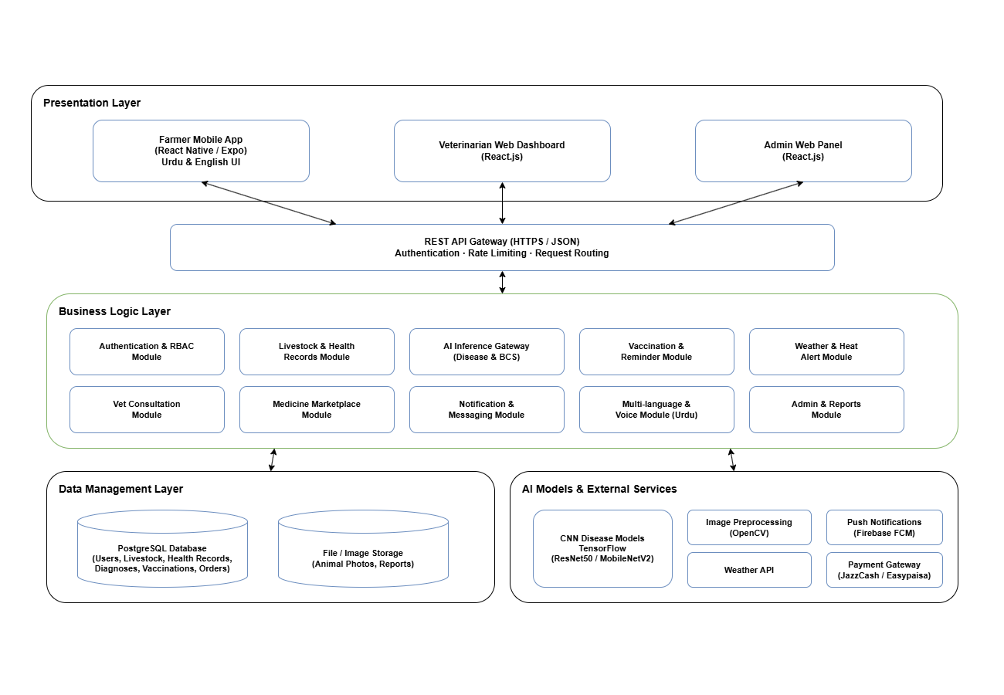

- Implementation Tools and Techniques
The development of the AgriDoctor system is carried out through a structured methodology. This methodology includes the application of agile software development principles along with the incorporation of a modular system. The entire project is divided into smaller phases to ensure the development of the entire system. This includes the mobile app, web dashboard, backend, and AI components.

Methodology

Agile Development
Maveshi Sehat AI is developed using Agile Scrum methodology with 8 two-week sprints over 4 months of active development. Each sprint follows: Sprint Planning → Daily Standups → Development → Sprint Review → Retrospective. A Kanban board (Trello/Jira) tracks all user stories and backlog items.

Modular Design
The entire system is divided into smaller modules. This ensures the development of the entire system. This includes the mobile app, web dashboard, AI module, database, etc.

Cloud Deployment
The entire system is deployed on cloud platforms. This ensures the entire system is scalable. This provides the necessary security to the farmers, veterinarians, and administrators.

Implementation Tools
Front-end Development:
- React Native for cross-platform development of a mobile application for the Farmer interface.
- React.js for development of web-based dashboards for the Veterinarian and Admin interfaces.

Back-end Development:
- Node.js / Django REST Framework for development and implementation of APIs for integration and communication between different modules and for authentication and authorization.

AI and Image Processing:
- TensorFlow / PyTorch for development and implementation of machine learning algorithms for detecting diseases, body scoring, and heat stress prediction.
- OpenCV for image processing and segmentation.

Database and Storage:
- MongoDB / PostgreSQL for storage and management of animal health records, vaccination schedules, and user information.
- Cloud Storage for secure storage and management of images of livestock using AWS S3 and Azure Blob Storage.

Cloud Services:
- AWS / Azure / Render for deployment and scalability of the system and for monitoring and performance optimization.
- Firebase Cloud Messaging for push notifications for alerts and reminders for vaccinations.

Design and Modeling Tools:
- Figma for UI/UX design and prototyping for development of user interfaces for the mobile and web applications.
- Draw.io for UML diagramming and modeling for system architecture.

LAYER | TECHNOLOGY | PURPOSE
Frontend (Mobile) | React Native | Cross-platform farmer mobile app (Android/iOS). Supports low-end devices.
Frontend (Web) | React.js + Tailwind CSS | Veterinarian telemedicine dashboard, NGO analytics dashboard, and admin control panel.
Backend | Node.js | REST API services, authentication (JWT), role-based access control, business logic.
AI — Image Classification | TensorFlow 2.x / PyTorch | CNN-based disease detection (ResNet50, MobileNetV2), BCS regression models.
AI — NLP Chatbot | Hugging Face Transformers (mBERT/IndicBERT) | Multilingual AI chatbot supporting Urdu and Punjabi for farmer assistance.
AI — Prediction | Scikit-learn | Heat stress prediction (Random Forest, Gradient Boosting, Logistic Regression).
Image Processing | OpenCV | Preprocessing pipeline: resizing, noise reduction, normalization, segmentation.
Database (SQL) | PostgreSQL | Animal health records, user data, vaccination schedules, disease logs, forum posts. Order transactions, payments, structured analytics, admin reporting.
Payment Gateway | JazzCash & Easypaisa SDK | Pakistan-native mobile payment integration for medicine marketplace.
Image Storage | AWS S3 / Azure Blob | Secure cloud storage for livestock images and AI model artifacts.
Push Notifications | Firebase Cloud Messaging (FCM) | Vaccination reminders, disease alerts, heat stress warnings, order notifications.
SMS Notifications | Twilio / Jazz SMS API | SMS fallback for farmers with limited smartphone connectivity.
Cloud Deployment | AWS EC2 / Azure App Service | Scalable cloud hosting for API servers, AI inference engines, and databases.
CI/CD | GitHub Actions | Automated testing, build, and deployment pipelines.
UI/UX Design | Figma | Wireframes, prototypes, and design system for mobile and web interfaces.
Version Control | Git + GitHub | Source code management, feature branching, code reviews.

- Project Plan
A structured approach for the management of the project will be adopted, which involves the use of a Work Breakdown Structure (WBS) for the decomposition of the work, as well as a Gantt Chart for the visualization of the work schedule.
  - Work Breakdown Structure
We broke down the AgriDoctor project into smaller parts in order to ensure that all aspects of the system are developed correctly. The Work Breakdown Structure comprises all activities related to project management, documentation, system development, testing, and submission of the project. This ensures that 100% of the project scope is covered.
- Project Management
  - Preparation of Work Breakdown Structure
  - Preparation of Project Proposal
  - Project Planning and Scheduling
- Reports / Documentation
  - Final Documentation Introduction
  - Market Survey (Livestock health practices)
  - Requirements Analysis (Farmer, Vet, Admin needs)
  - System Design (Architecture, UML diagrams)
  - Implementation (Frontend, Backend, AI Models)
  - Testing & Performance Evaluation
  - Conclusion & Outlook
  - End User Documentation (Farmer App Guide)
  - Application Administration Documentation (Admin Panel Guide)
  - System Administrator Documentation (Deployment Guide)
- System
  - Development Environment
    - React Native (Farmer Mobile App)
    - React.js (Vet & Admin Dashboards)
    - Node.js/Django REST (Backend APIs)
    - MongoDB/PostgreSQL (Database)
    - Cloud Deployment (AWS/Azure/Render)
  - Presentation Layer
    - Farmer Mobile Interface
    - Veterinarian Dashboard Interface
    - Admin Panel Interface
  - Business Logic Layer
    - Image Upload & Session Control
    - Disease Detection Logic
    - Vaccination Reminder Logic
    - Medicine Ordering & Inventory Control
  - Data Management Layer
    - Database Schema Design
    - Health Record Storage System
    - Inventory Records
    - User & Role Data
  - Physical Layer
    - Image Preprocessing (OpenCV)
    - Disease Detection Models (TensorFlow/PyTorch)
    - Push Notification Service (Firebase/AWS SNS)
    - Farmer Mobile Devices
    - Veterinarian PCs/Tablets
    - Admin Computer System
    - Internet / WiFi Network
    - Cloud Services

Roles & Responsibility Matrix:
WBS # | WBS Deliverable | Activity # | Activity to Complete the Deliverable | Duration  (# of Days) | Responsible Team Member(s) & Role(s)
1.1 | Proposal | A1 | Decide project idea | 3 | All members
1.2 | Proposal | A2 | Write proposal | 5 | Awais Shabbir
1.3 | Proposal | A3 | Make work plan (WBS) | 3 | Gulraiz + Wahib Ali
1.4 | Proposal | A4 | Make timeline chart (Gantt) | 3 | Gulraiz
1.5 | Proposal | A5 | Prepare for proposal defense | 4 | All members
1.6 | Project Management | A6 | Weekly team meetings | Ongoing | Gulraiz
1.7 | Project Management | A7 | Handle risks and changes | 5 | All members
2.1 | Documentation (SRS) | A8 | Study requirements | 7 | Gulraiz + Wahib
2.2 | Documentation (SRS) | A9 | Draw use case diagram | 4 | Awais Shabbir
2.3 | Documentation (SRS) | A10 | Draw activity diagram | 4 | Awais Shabbir
2.4 | Documentation (SRS) | A11 | Draw sequence diagram | 4 | Gulraiz
2.5 | Documentation (SRS) | A12 | Draw class diagram | 5 | Wahib Ali
2.6 | Documentation (SRS) | A13 | Draw ER diagram | 5 | Wahib Ali
2.7 | Documentation (SRS) | A14 | Draw system architecture | 5 | Gulraiz
2.8 | Documentation (SRS) | A15 | Draw component diagram | 5 | Wahib
2.9 | Documentation (SRS) | A16 | Write feature list | 5 | Awais Shabbir
2.10 | Documentation | A17 | Do literature review & survey | 7 | Gulraiz + Awais
2.11 | Documentation | A18 | Write draft SRS | 10 | Gulraiz + Awais
2.12 | Documentation | A19 | Submit final SRS | 5 | Gulraiz (Lead)
3.1 | Development | A20 | Setup backend | 7 | All members
3.2 | Development | A21 | Build database | 10 | All members
3.3 | Development | A22 | Make farmer app | 14 | Gulraiz + Awais
3.4 | Development | A23 | Make vet dashboard | 14 | Gulraiz + Awais
3.5 | Development | A24 | Make admin panel | 12 | Wahib Ali
3.6 | Development | A25 | Make inventory module | 12 | Gulraiz + Awais
3.7 | Development | A26 | Build AI model | 20 | Gulraiz
3.8 | Development | A27 | Deploy on cloud | 10 | Awais + Wahib
3.9 | Development | A28 | Add push notifications | 7 | Awais Shabbir
3.10 | Development | A29 | Add login & security | 10 | Gulraiz
4.1 | Testing | A30 | Do unit testing | 7 | All Members
4.2 | Testing | A31 | Do integration testing | 7 | All Members
4.3 | Testing | A32 | Check performance | 7 | Gulraiz + Awais
4.4 | Testing | A33 | Do security testing | 5 | Wahib Ali
4.5 | Testing | A34 | Fix bugs and improve | 10 | All Members
5.1 | Final Submission | A35 | Write final report | 10 | All Members
5.2 | Final Submission | A36 | Finish GUI | 7 | Wahib Ali
5.3 | Final Submission | A37 | Finalize code | 7 | Gulraiz + Awais
5.4 | Final Submission | A38 | Prepare final presentation | 5 | All Members
5.5 | Final Submission | A39 | Write user guide | 7 | Awais + Gulraiz

SPRINT BASE:
Sprint | Duration | Key Deliverables | Owner
Sprint 1 | Weeks 5–6 | Dev environment setup, MongoDB & PostgreSQL schema design, React Native/Node.js/React.js project scaffolding, GitHub repo structure, CI/CD baseline | All Members
Sprint 2 | Weeks 7–8 | JWT authentication (farmer/vet/admin roles), user registration & login APIs, role-based access control, Postman API testing suite | Gulraiz
Sprint 3 | Weeks 9–10 | Livestock disease image dataset collection (1,500+ images), data labeling & augmentation, OpenCV preprocessing pipeline, initial CNN model training (ResNet50) | Awais + wahib
Sprint 4 | Weeks 11–12 | Farmer mobile app core screens: image capture & upload, AI result view, health record creation, vaccination reminders, basic navigation; NLP chatbot (Urdu) prototype | Gulraiz + Awais
Sprint 5 | Weeks 13–14 | Veterinarian telemedicine dashboard, admin panel (user mgmt., analytics), vet consultation request flow, prescription issuance UI, admin revenue dashboard | Gulraiz + Awais
Sprint 6 | Weeks 15–16 | AI model fine-tuning (MobileNetV2 + Ensemble), BCS module integration, heat stress prediction (Random Forest), medicine marketplace (catalog, cart, JazzCash/Easypaisa payment) | All Members
Sprint 7 | Weeks 17–18 | Community forum module, Firebase FCM + SMS notifications, full cloud deployment (AWS/Azure), performance optimization, CDN configuration, load testing baseline | Awais + Wahib
Sprint 8 | Weeks 19–20 | Comprehensive unit & integration testing, security audit (JWT, SQL injection), UI/UX polish, bug resolution, final demo environment, user acceptance testing with pilot farmers | All Members

  - Gantt Chart

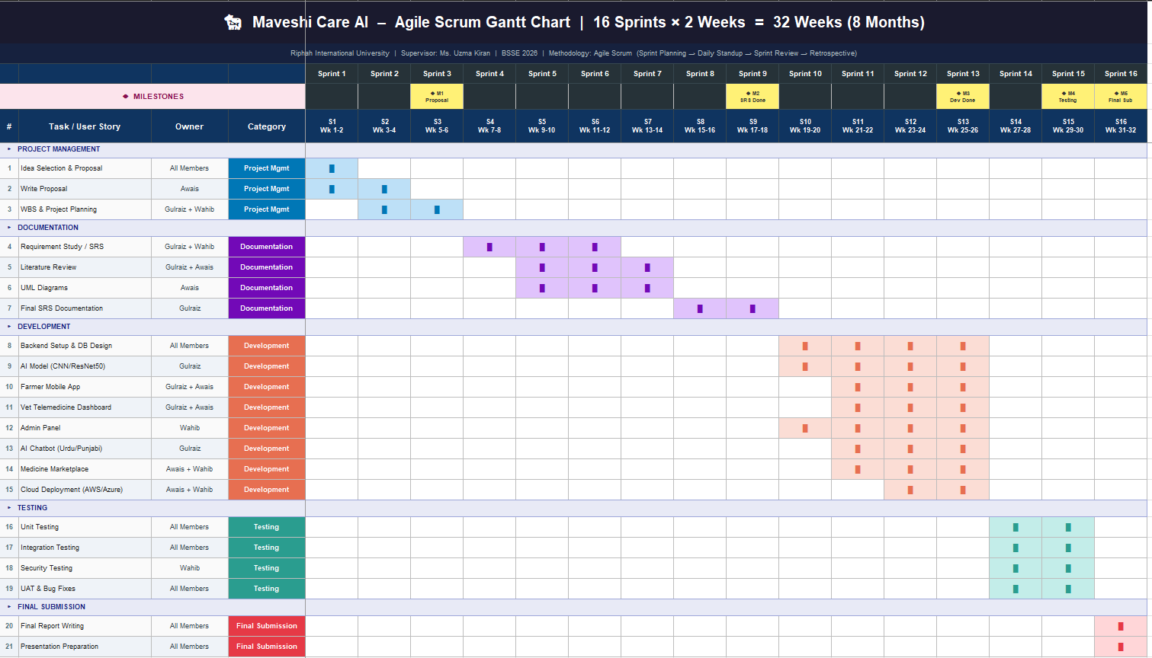

8.3 Milestones
Milestone | Description | Timeline
Proposal Approval | Approval of project idea and proposal defense | Month 1
SRS Completion | Completion of Software Requirement Specification and diagrams | Month 3
System Development Completion | Mobile app, dashboard, backend and AI model implemented | Month 6
Testing Completion | Unit testing, integration testing, and security testing completed | Month 7
Final Submission | Final report submission and project defense | Month 8
References
Food and Agriculture Organization. (2023). The State of Food and Agriculture 2023. Rome: FAO.

Pakistan Bureau of Statistics. (2022). Pakistan Economic Survey: Livestock Sector Contribution. Government of Pakistan.

World Bank. (2022). Agriculture and Livestock Development Report. Washington, DC.

Yann LeCun, Yoshua Bengio, & Geoffrey Hinton. (2015). Deep learning. Nature, 521(7553), 436–444.

Karen Simonyan, & Andrew Zisserman. (2014). Very deep convolutional networks for large-scale image recognition. International Conference on Learning Representations (ICLR).

List of Faculty Proposed Changes
Project Title

Proposed Change | Proposed By | Supervisor’s Decision
 | Name of Faculty Member(s) who proposed this change | Approved/Disapproved and/or Comments

Date: __________________ Supervisor’s Signature: ______________

APPROVAL
Project Supervisor
Comments: ___________________________________________________________________
_____________________________________________________________________________
_____________________________________________________________________________
_____________________________________________________________________________
Name:______________________________
Date:_______________________________ | Signature:__________________________

Project Manager
Comments: ___________________________________________________________________
_____________________________________________________________________________
_____________________________________________________________________________
_____________________________________________________________________________
_____________________________________________________________________________
Date:_______________________________ | Signature:__________________________

